Q: What is SignUp Genius?
A: SignUp Genius is the app we use to manage sign-ups and communicate about PCVG events. To get started, simply create an account by clicking here. It’s quick and easy!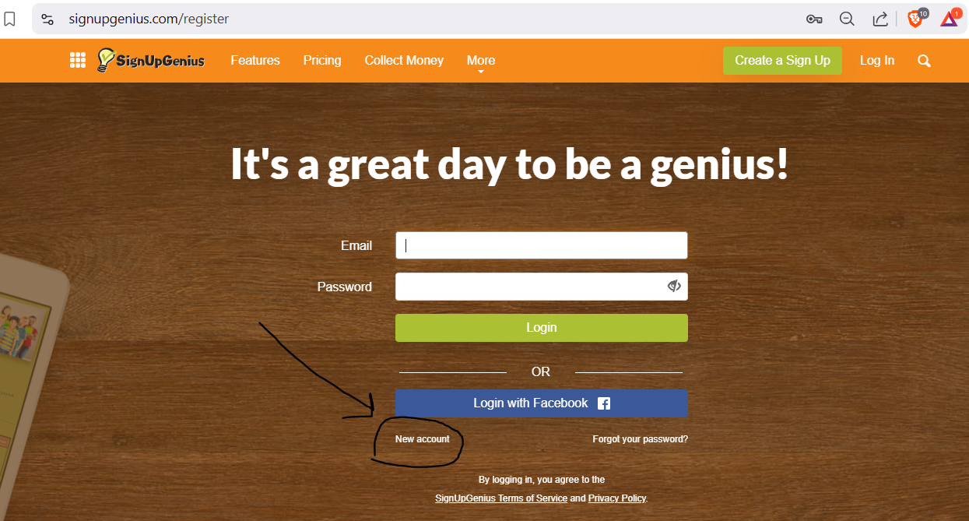
Q: How do I sign up for PCVG Drills, Clinics, and other Pickleball events?
A: How to Sign Up for PCVG Events:
To make sure your registration is properly linked to your SignUp Genius account, follow these steps:
- First, Sign In to SignUp Genius – this is an important step*
Log in to your SignUp Genius account before clicking on any event links. This ensures your registration is connected to your account.
- Click the Event Link on the PCVG Website
Once you're signed in, go to the PCVG website and click the link for the event you’d like to register for. This will direct you to the event registration page on SignUp Genius.
- Why Sign In First?
Signing in before registering guarantees that your event registration is linked to your account. This is important for receiving reminders and any system-generated updates, like event changes or cancellations.
- Even if the Waitlist appears to have a lot of people, if you want to attend the session, put yourself on the Waitlist.
People cancel, right up to the morning of a session, for a lot of different reasons. We sometime find ourselves chasing around for a person to fill a last-minute opening. Also, we use the size of the Waitlist to gauge interest in the events. We use this information to help determine where to put our resources.
*If you don't sign in first, SignUp Genius will prompt you for your email address. When entering it, there’s a risk of a typo. If there’s an error, SignUp Genius will still accept the incorrect email, but it won't link to a valid address. As a result, you won’t receive a confirmation email, won’t see the sign-up in your account, won’t be able to cancel, and won’t get the reminder email.
By following the steps above you’ll stay up-to-date and avoid any registration issues.

Q: All I see is last week’s event on SignUp Genius. How do I get to the SignUp for the correct event?
A: Look at the date of the event in the header or tab
On the Mobile App it looks like this: Click the date (highlighted), pick the date you want and click GO! Now the event on the correct date is active and ready for you to sign up.
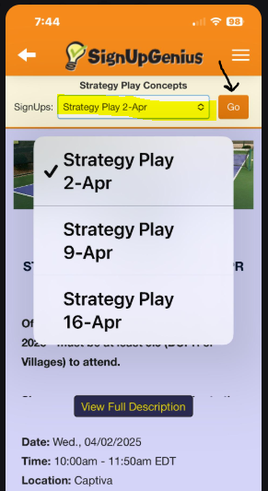
On a device with a larger display, the various dates are on Tabs that look like this:

Q: I have a schedule conflict. How do I cancel or remove myself from the waitlist
A: Sign Ups close at 4pm the evening before the event.
If you need to cancel, and the Sign Up is still open:
- From the Web App: Sign into your SignUp Genius account. Go to the “Invited to” tab. See the screen shot below. Click the X and follow the rest of the system prompts.
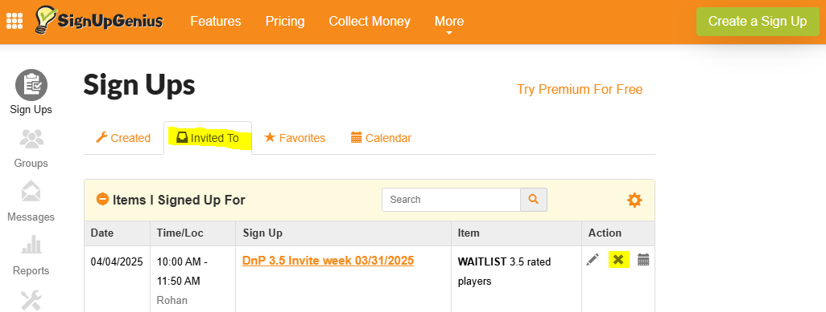
- From the Mobile App: See below screen shot. Click the event name hyperlink and go to the Sign Up event. Then click the Delete button.
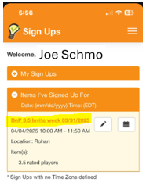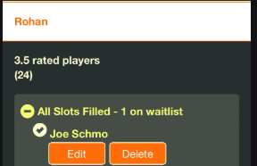
If you need to cancel, and the SignUp is closed:
From the Web App or the Mobile App: Click the envelope next to the Contact and follow the rest of the system prompts to email your cancelation notification to the PCVG Admin responsible for the event.
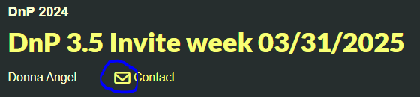

Q: How do I know if I got into the event or that I am on the Waitlist?
A: Immediately after you sign-up, SignUp Genius sends an email confirmation. See sample below says Waitlist.
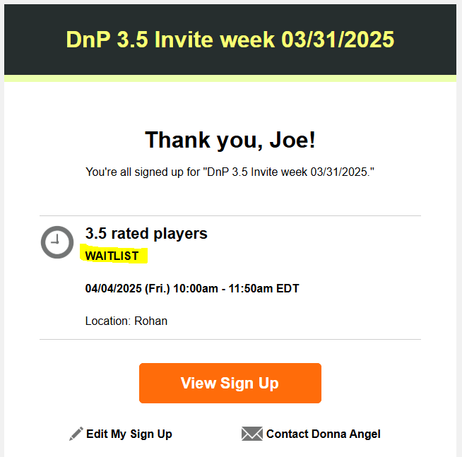
To keep a watch on your status as the event approaches, on the Web App: Sign into your SignUp Genius account and go to the “Invited to” tab. See example below.
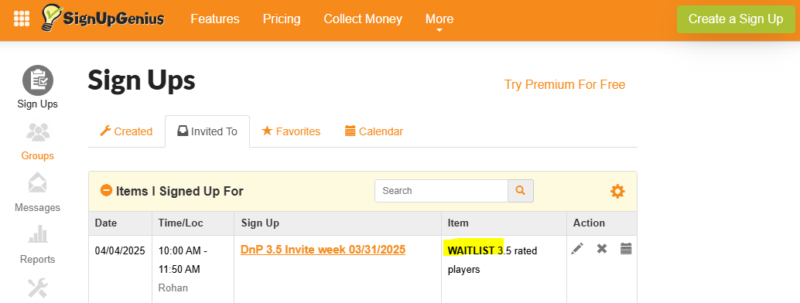
Click on the event name hyperlink. See screen shot below. It says #1 on the Waitlist; this means YOU are #1 on the Waitlist. 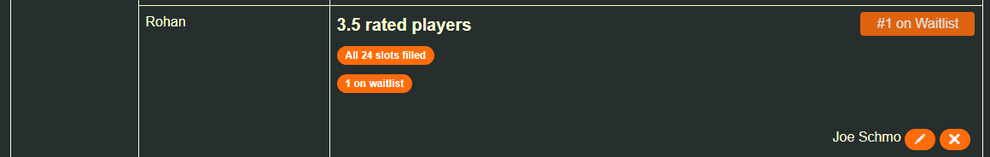These views are not available on the Mobile App. PCVG Administration is working with SignUp Genius to improve the Mobile App views related to the Waitlist.

Q: I struggle to get into a very popular event. It seems like the same people are getting in each week and I always end up on the Waitlist. What gives?
A: All events open at their scheduled time automatically, as this is controlled by the system—there’s no manual intervention. Some events fill up within seconds, especially during the "high season" (January to March). Every entry on SignUp Genius is time-stamped, and players are confirmed as soon as they press <ENTER>. Once an event reaches capacity, subsequent sign-ups are added to the Waitlist. Factors like network speed, whether you're using the mobile or web app, and your typing speed all influence how quickly you can secure a spot. With so many events available, don’t get discouraged—just try signing up for another one!

Q: How will I know if there is a cancellation, and I am confirmed for the event?
A: You will receive an email from SignUp Genius once you're removed from the Waitlist and your spot in the event is confirmed.

Q. I missed an event and forgot to cancel my SignUp. What happens now?
A: If you're unable to attend an event, please cancel in advance via the app or by notifying the event contact. Instructors plan for four players per court, and there may be others on the waitlist eager to participate.
Failure to cancel in advance is considered a "No Show." In such cases, the PCVG Admin will inform you of a temporary restriction on signing up for any PCVG event. During the restriction period, if a spot is available the day before an event, you can email the event contact to inquire about filling the spot or show up at the courts in case of a No Show.

Q. An event I have been enjoying is not available next week. What’s up?
A: The event schedule varies by season. During the fall and winter months—when The Villages sees its highest population—events are held more frequently. From May through September, they occur less often. There are also short breaks between seasons and periodic Rec Center maintenance can interrupt the schedule. For the most up-to-date schedule, visit the Pickleball Community website.

